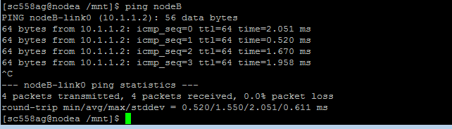

Practically average RTT = 1.550ms

Theoretically bandwidth-delay product is 100Mbps * 1.550ms /(8*1024) = **18.92 KBytes**

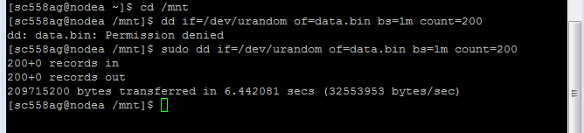

|  |  |
| --- | --- |
| **Delay(RTT)ms** | **Theoretical Bandwidth-delay product(KBytes)** |
| **1.594** | **18.92** |
| **20** | **244.14** |
| **40** | **488.28** |
| **50** | **610.35** |
| **60** | **732.42** |

**Before setting the window size settings in kernel: DEFAULT**

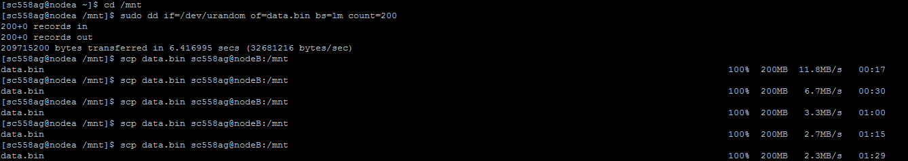

**After maximum window size settings in kernel set to 2Mbytes.**

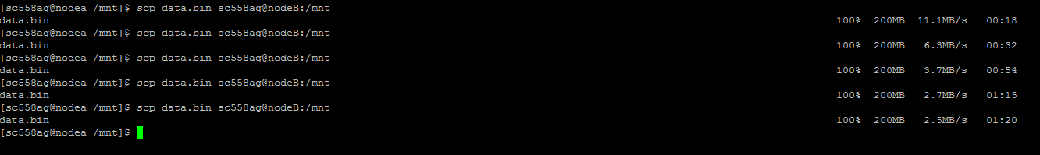

**These all values obtained were at default sender and receiver window size of 32KB.**

**At RTT=1.594ms, changing the default sender and receiver window sizes to 64KB,128KB,256KB,512KB.**

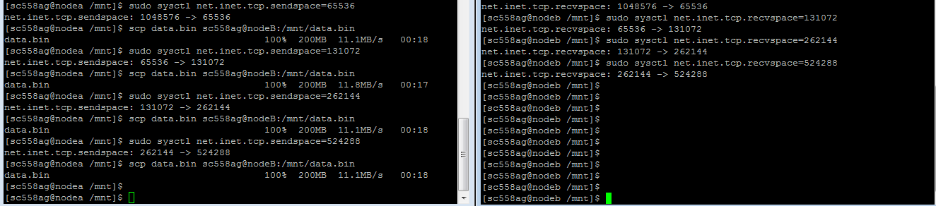

**At RTT=20ms, changing the default sender and receiver window sizes to 64KB,128KB,256KB,512KB.**

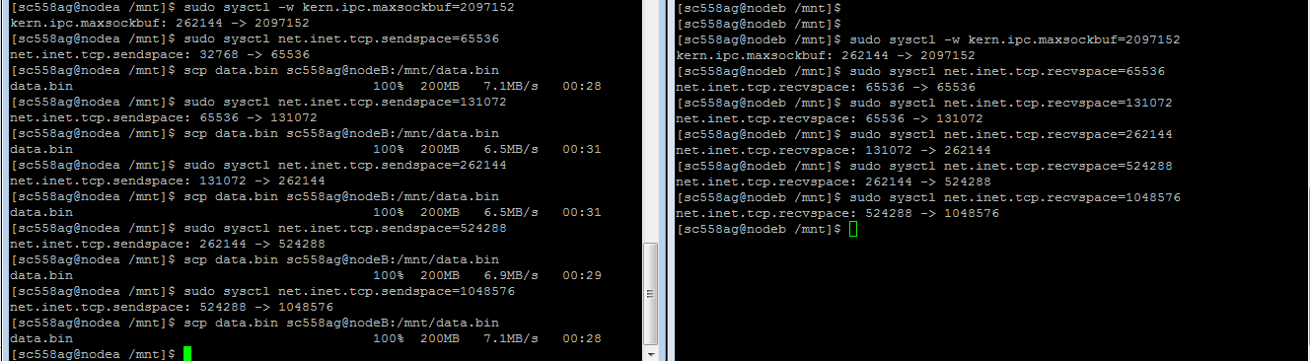

**At RTT=50ms, changing the default sender and receiver window sizes to 64KB,128KB,256KB,512KB.**

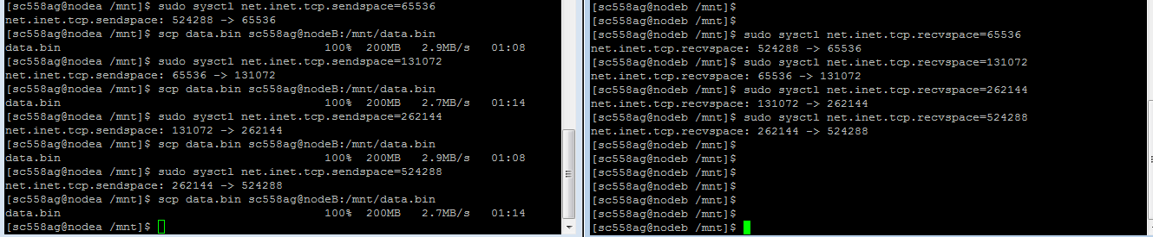

**Even for RTT=60ms, the throughputs remained the same for sender and receiver window sizes = 64KB, 128KB, 256KB and 512KB.**

**Keeping in mind that the receiver and sender window sizes should be less than or equal to theoretical band-width delay product, we took the following observations:**

**For 20ms**

**Keeping window size to 240KB: (theoretically 244KB)**



**For 40ms**

**Keeping window size to 480KB: (theoretically 488KB)**



**For 50ms**

**Keeping window size to 608KB: (theoretically 610KB)**



**For 60ms**

**Keeping window size to 730KB: (theoretically 732KB)**



**Loss vs Throughput:**

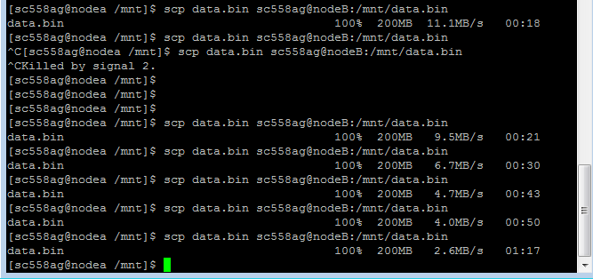

|  |  |
| --- | --- |
| **Loss(%)** | **Throughput(MB/s)** |
| **0.01** | **11.1** |
| **1.00** | **9.5** |
| **2.00** | **6.7** |
| **3.00** | **4.7** |
| **4.00** | **4.0** |
| **5.00** | **2.6** |

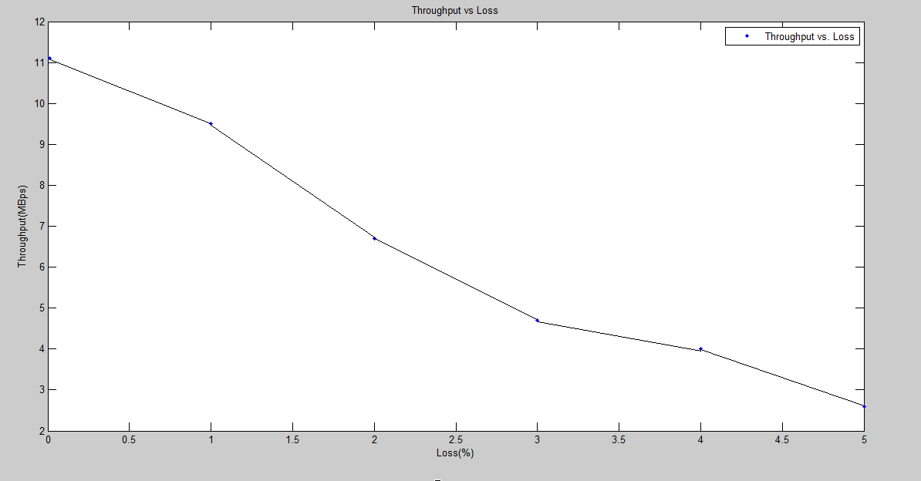

**Pinging CERN (80.74.128.12): Average RTT is 181.715ms.**

